Manager’s Column
Adobe Press; Inside the NCSD
March 25, 2016 Issue

SPRING TUNE-UPS
The mission of the Nipomo Community Services District is to provide its customers with reliable, quality, and cost-effective services now and in the future.
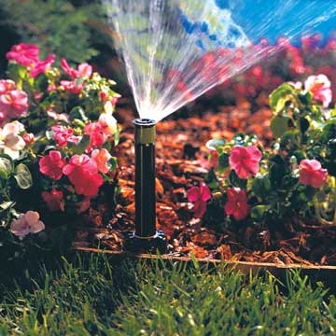
Spring is in the air! Now that the clocks have been changed, have you checked to make sure your irrigation timer is set appropriately? Spring is a great time to give that system a look-over and make any needed adjustments.
It is also a great time to walk around your property and check for any leaks. The District reads water meters once every two months for billing purposes. If a leak develops on the customer side of the meter and goes undetected until the next regular meter read, large of amounts of water could be consumed by the customer leading to large water bills.
Most large leaks involve landscape irrigation systems - including lateral lines to remote hose connections. On this sand dune we affectionately call ‘The Mesa’, water infiltrates very quickly and even large leaks can go undetected. Many smaller leaks or simply over-watering occur routinely in many homes.
Inside the home, toilets are often “silent leakers” and can go undetected. The District has some toilet tabs available that will help you check your toilets. Another tough-to-detect leak can occur within water softener equipment when flushing of the system occurs excessively or continuously.
A customer’s best defense against overwatering or a major water leak and a devastating water bill is knowledge. If you have an irrigation system or water softener, make sure someone in the home is familiar with the operation and is checking and making seasonal adjustments.
Being aware of your typical household water use will help you know if and when the use is up unexpectedly. The water meter at your property is a tool that can help you determine if a leak has developed in your system. The District has helpful information on how to read the meter. Visit us online or stop by the office.
Water is precious and money is hard earned – saving water can save you money!
Until next time…
Mario Iglesias, General Manager, info@ncsd.ca.gov Follow us on or NipomoCSD

